Name-Zaid Ahmed Khan

Roll No-21CH10079

I have used Dark Channel Prior(DCP) for image dehazing . There are five major steps in DCP namely, airlight estimation, dark channel estimation, coarse transmission estimation, transmission refinement, and scene recovery. For an image J, the estimation of the dark channel is as shown below where Jc(y) represents the color channel of J and Ω(x) is a local patch anchored at x. 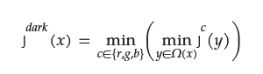

According to observation in the value of Jdark is low and tends to be zero except for the sky region if J is a haze-free outdoor image. Then, the dark channel prior and the imaging hazy model are combined together. After some simplification transmission t ̃(x) comes out to be :

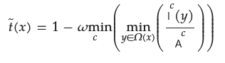

Where omega is a constant and in my program I have taken it as 0.95

For calculation Atmospheric Light we have first pick the top 0.1% brightest pixels in the dark channel. These pixels are most hazeopaque in Among these pixels, the pixels with highest intensity in the input image I is selected as the atmospheric light.

Then I have make use of guided filter and inbuild boxFilter .

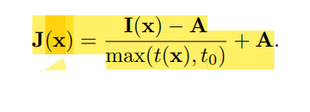I have tried to implement this method for video but the output was not which was expected .

